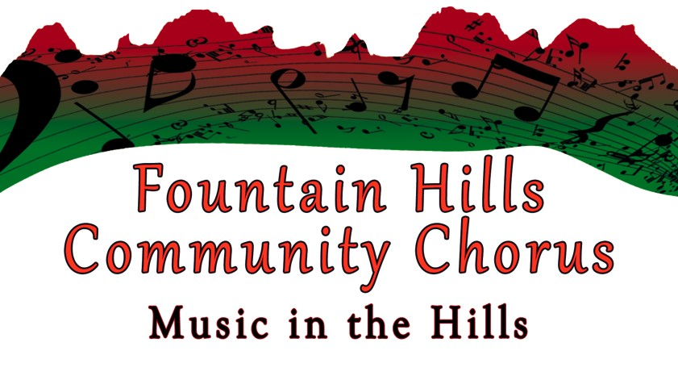

**FOUNTAIN HILLS COMMUNITY CHORUS**

**SCHEDULE – FALL 2024**

**All functions are at the Fountain Hills Community Center**

**Monday weekly rehearsals are in the Pima & Hopi Rooms**

**Rehearsals** **Mondays,** **5:30-7:30 pm**

September 9, 16, 23, 30

October 7, 14, 21, 28

November 4, 11 (Veterans Day, Alternate location TBD), 18, 25

December 2

**Sectionals**

Saturday, October 19

Tenors & Bases 8:30-10 am

Sopranos & Altos 10-11:30 am

**Fall Concert Information**

Saturday, December 7th, 4-6 pm Stage Rehearsal

Sunday, December 8th, 1st Fall Concert 3 pm Warm Up - 4 pm Performance

Monday, December 9th, 2nd Spring Concert 6:30 pm Warm Up – 7 pm Performance

**SAVE THE DATES: Spring 2025 Session**

First Rehearsal and Registration January 6th 2025, 5 pm registration, rehearsal 5:30 pm

Concert Dates: Saturday, April 5th & Sunday, April 6th, both at 4pm